Practical 5: Registration Form with Frontend Validation and User-Friendly Error Handling
Problem Definition | Create a student registration form with HTML5 input types and JavaScript validation for name, email, mobile number, password, confirm password, course, year, gender, and terms acceptance. Use Regular Expression for validations.

A. Theory
1. Are correct input types and attributes used?
Answer: Yes. HTML5 input types and suitable attributes are used for fields such as email, mobile number, password, and other registration details.
2. Are validation errors displayed near the relevant fields?
Answer: Yes. Validation errors should be displayed near the relevant fields so that users can easily identify and correct invalid input.
3. Is password strength checked?
Answer: Yes. Password strength is checked during validation to ensure that the entered password meets the required conditions.
4. Is the form accessible using keyboard and screen-reader-friendly labels?
Answer: Yes. Proper labels and accessible form controls help users navigate the form using a keyboard and screen readers.
B. Implementation / Output / Result
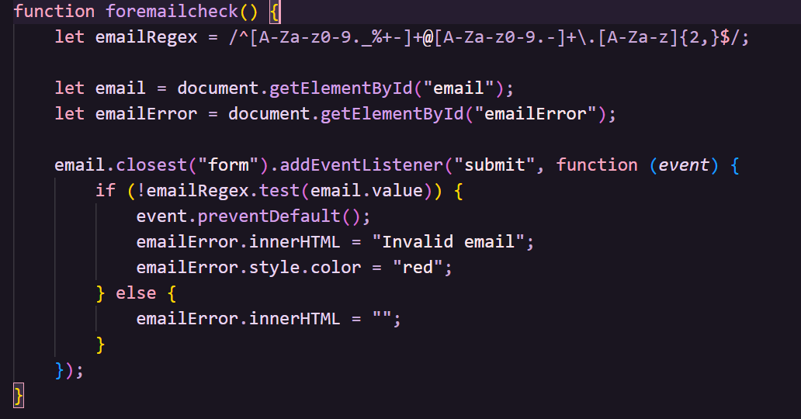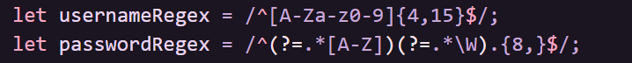
C. Evidence of Work (Screenshots)

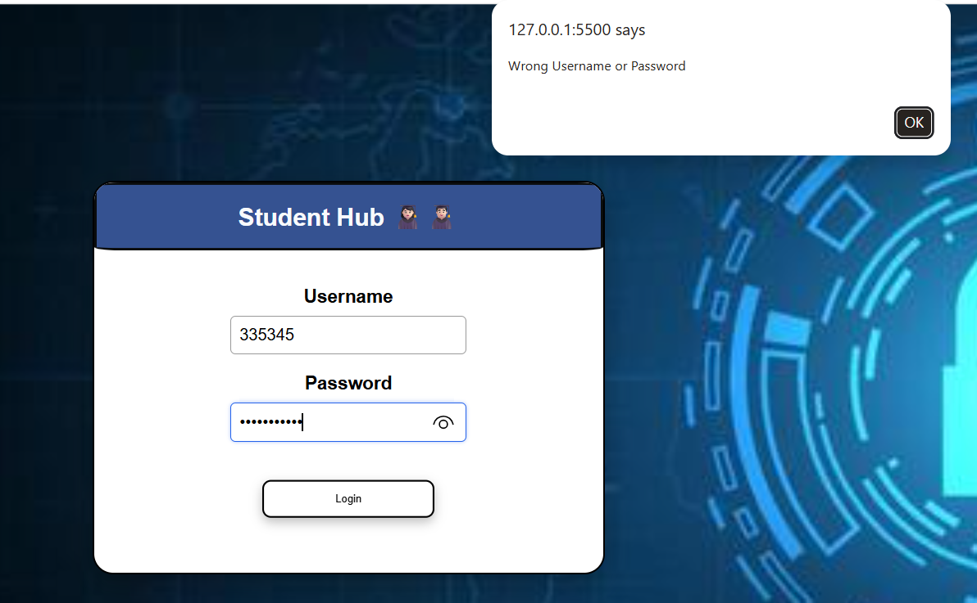
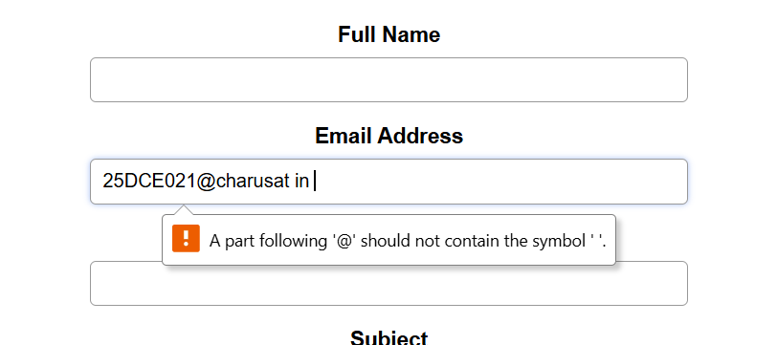
D. GitHub Repository Link:
https://github.com/AD-9218/Student-Hub/tree/main/Practical-5
E. Challenges Faced:
I faced some difficulty in applying JavaScript validation to all form fields and writing the correct regular expressions. I also had challenges in displaying error messages near the relevant fields and checking password strength. After testing valid and invalid inputs, I fixed the validation issues.
F. Learning Outcomes:
I learned how to create a student registration form using HTML5 and validate form data using JavaScript. I also learned how to use regular expressions, password strength validation, accessible labels, and user-friendly error messages.
Faculty Remarks:

